Project Planning Phase
Project Planning Template (Product Backlog, Sprint Planning, Stories, Story points)

Date | 31 January 2026
Team ID | LTVIP2026TMIDS28502
Project Name | Visualizing Housing Market Trends: An Analysis of Sale Prices and Features using Tableau
Maximum Marks | 8 Marks

Product Backlog, Sprint Schedule, and Estimation (4 Marks)
Use the below template to create product backlog and sprint schedule
Sprint | Functional Requirement (Epic) | User Story Number | User Story / Task | Story Points | Priority | Team Members
Sprint-1 | Data Collection | USN-1 | As a user, I can load the housing dataset into Tableau Desktop | 3 | High | Mathineni Karthik
Sprint-1 | Data Preparation | USN-2 | As a user, I can clean and prepare the dataset for visualization | 3 | High | Shaik Saida
Sprint-1 | Basic Visualization | USN-3 | As a user, I can create KPI visualizations such as total houses and average sale price | 4 | High | Ravulapalli Hemachand
Sprint-1 | Chart Creation | USN-4 | As a user, I can create charts such as bar charts and pie charts | 4 | High | Vakada Srinu
Sprint-2 | Dashboard Creation | USN-5 | As a user, I can create an interactive dashboard combining visualizations | 5 | High | Mathineni Karthik
Sprint-2 | Story Creation | USN-6 | As a user, I can create a Tableau Story to present insights step-by-step | 3 | Medium | Shaik Saida
Sprint-3 | Dashboard Publishing | USN-7 | As a user, I can publish dashboard to Tableau Public | 3 | High | Ravulapalli Hemachand
Sprint-3 | Web Integration | USN-8 | As a developer, I can integrate dashboard into Flask web application | 5 | High | Vakada Srinu
Sprint-4 | Testing | USN-9 | As a user, I can test dashboard functionality and interactivity | 3 | Medium | Mathineni Karthik
Sprint-4 | Documentation | USN-10 | As a user, I can prepare project documentation and demonstration | 4 | High | All Team Members

Project Tracker, Velocity & Burndown Chart: (4 Marks)
Sprint | Total Story Points | Duration | Sprint Start Date | Sprint End Date (Planned) | Story Points Completed | Sprint Release Date (Actual)
Sprint-1 | 14 | 6 Days | 24 Oct 2022 | 29 Oct 2022 | 14 | 29 Oct 2022
Sprint-2 | 8 | 6 Days | 31 Oct 2022 | 05 Nov 2022 | 8 | 05 Nov 2022
Sprint-3 | 8 | 6 Days | 07 Nov 2022 | 12 Nov 2022 | 8 | 12 Nov 2022
Sprint-4 | 7 | 6 Days | 14 Nov 2022 | 19 Nov 2022 | 7 | 19 Nov 2022

Velocity:
Imagine we have a 10-day sprint duration, and the velocity of the team is 20 (points per sprint). Let’s calculate the team’s average velocity (AV) per iteration unit (story points per day)
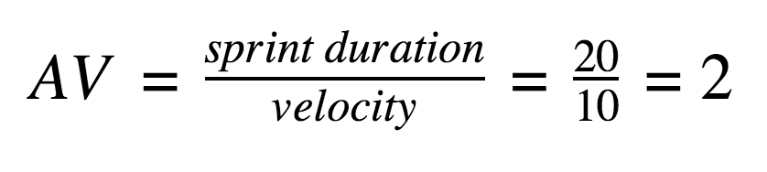
Total Story Points Completed = 37
Total Sprint Duration = 24 Days
Average Velocity (AV) per sprint =
AV = Total Story Points / Number of Sprints
AV = 37 / 4
AV = 9.25 story points per sprint
Average Velocity per day =
AV per day = 37 / 24 = 1.54 story points per day

Burndown Chart:
A burn down chart is a graphical representation of work left to do versus time. It is often used in agile software development methodologies such as Scrum. However, burn down charts can be applied to any project containing measurable progress over time.

